Erika Hernandez

Final Exam

NET 4740

Question 1 – List of users from each machine

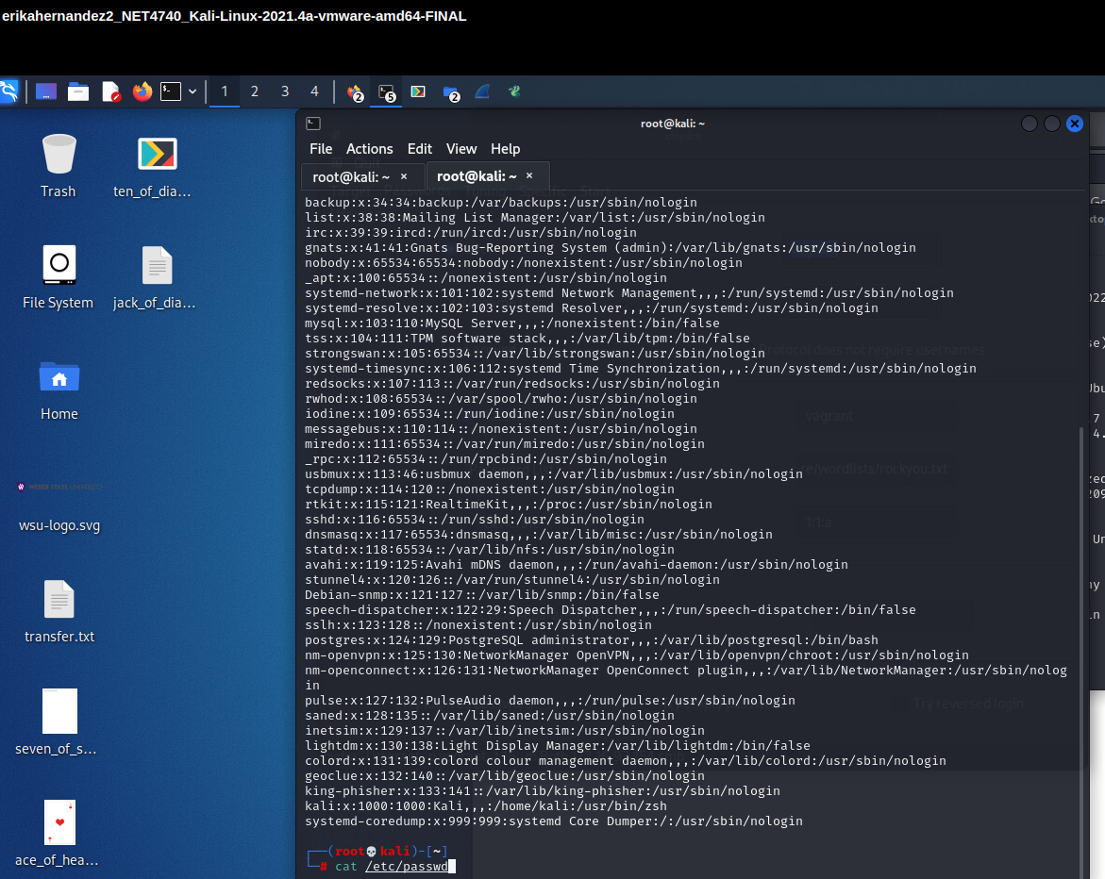Kali Linux users with root users

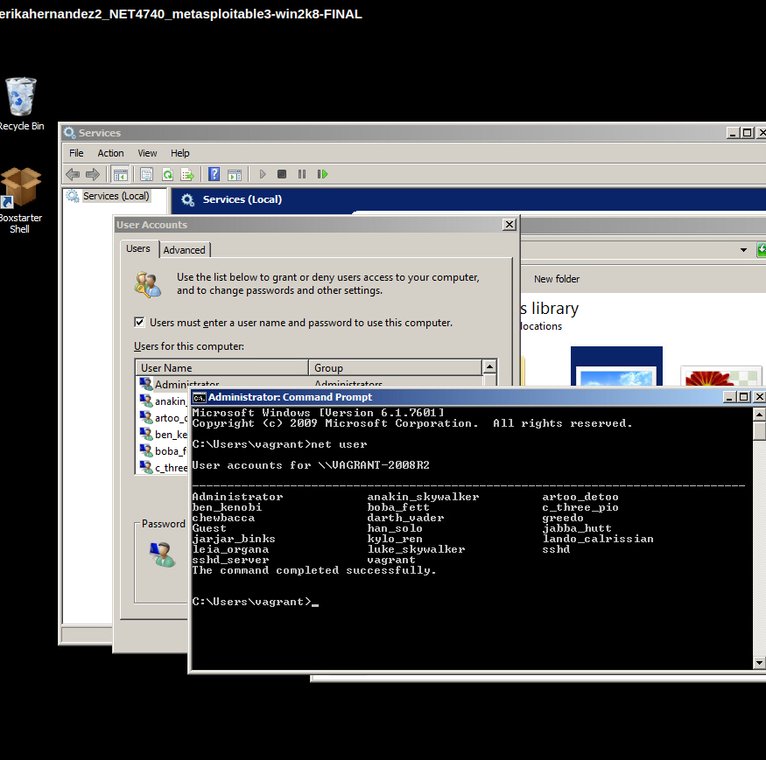Windows 2008- List of users for the window machine

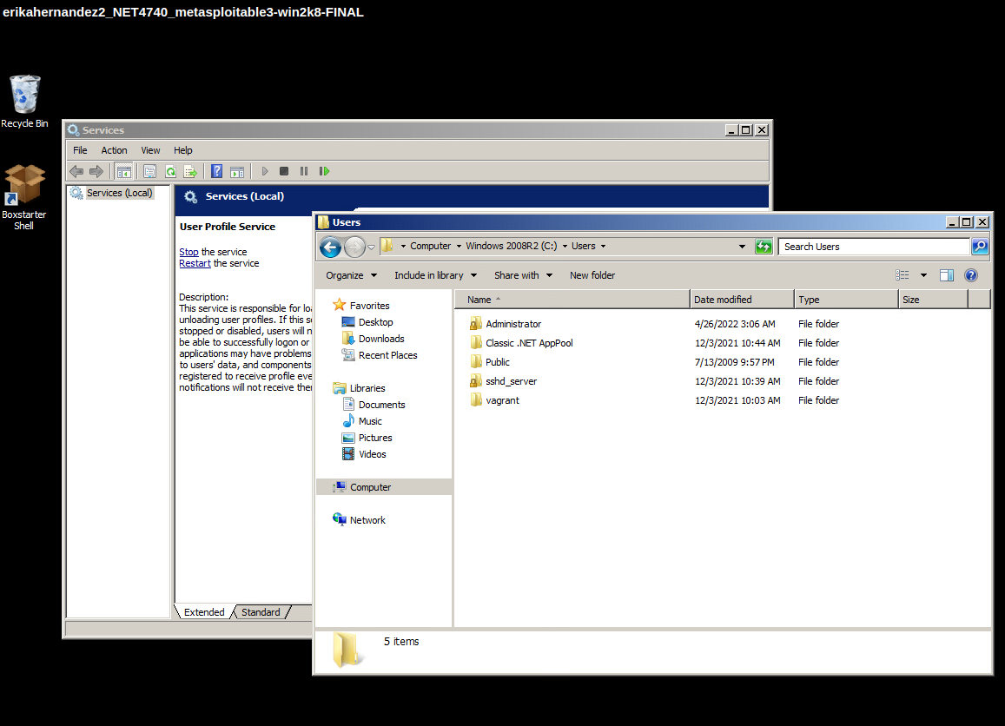Windows - Second method to finding users- wanted to double check on users

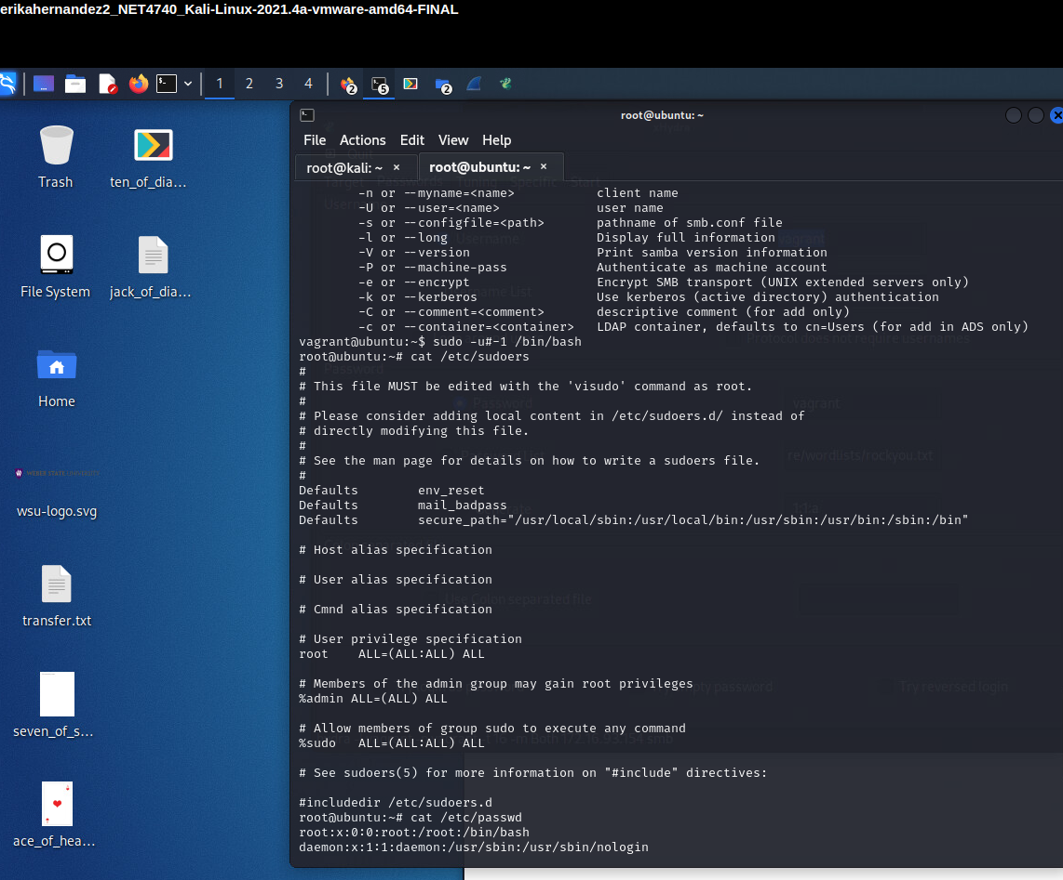Ubuntu Users - I coudn't get into root user in the Ubuntu machine so I ssh into it. using the vagrant@172.16.93.154

Question 2 – admin users
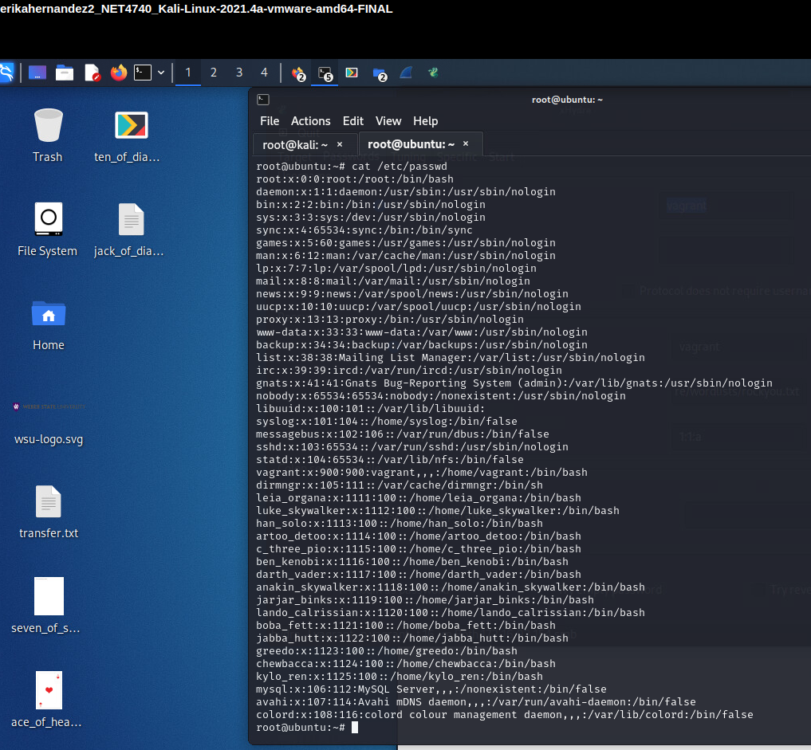Ubuntu as root- Here are the list of users using the root on the kali machine

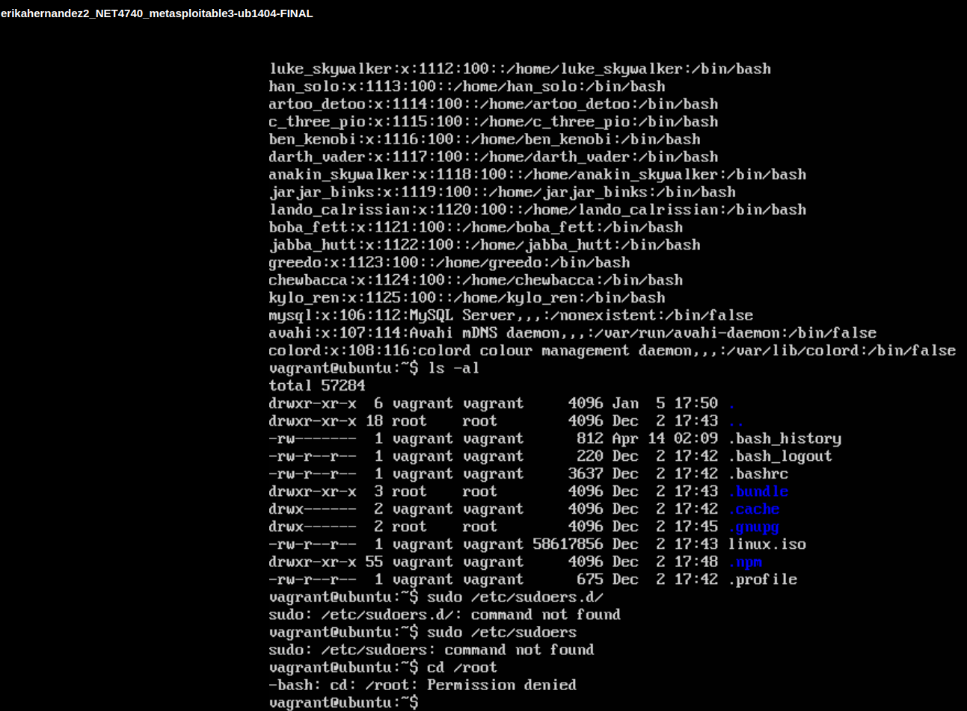Ubuntu access denied- Here is showing that it wont let me use root on the machine – using the sudoers.d command

Question 3 – Flags 1 and 2 – Two flags for each machine

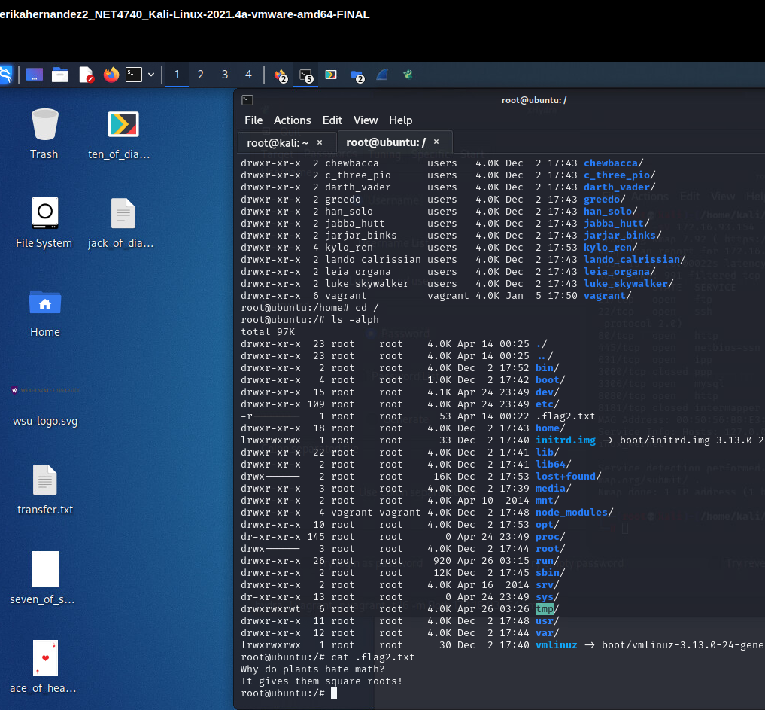Flag2.txt- The flag wouldn't open on the Ubuntu machine so i ssh it and send it over to the Kali machine. There i was able to open it and read the content of the file.

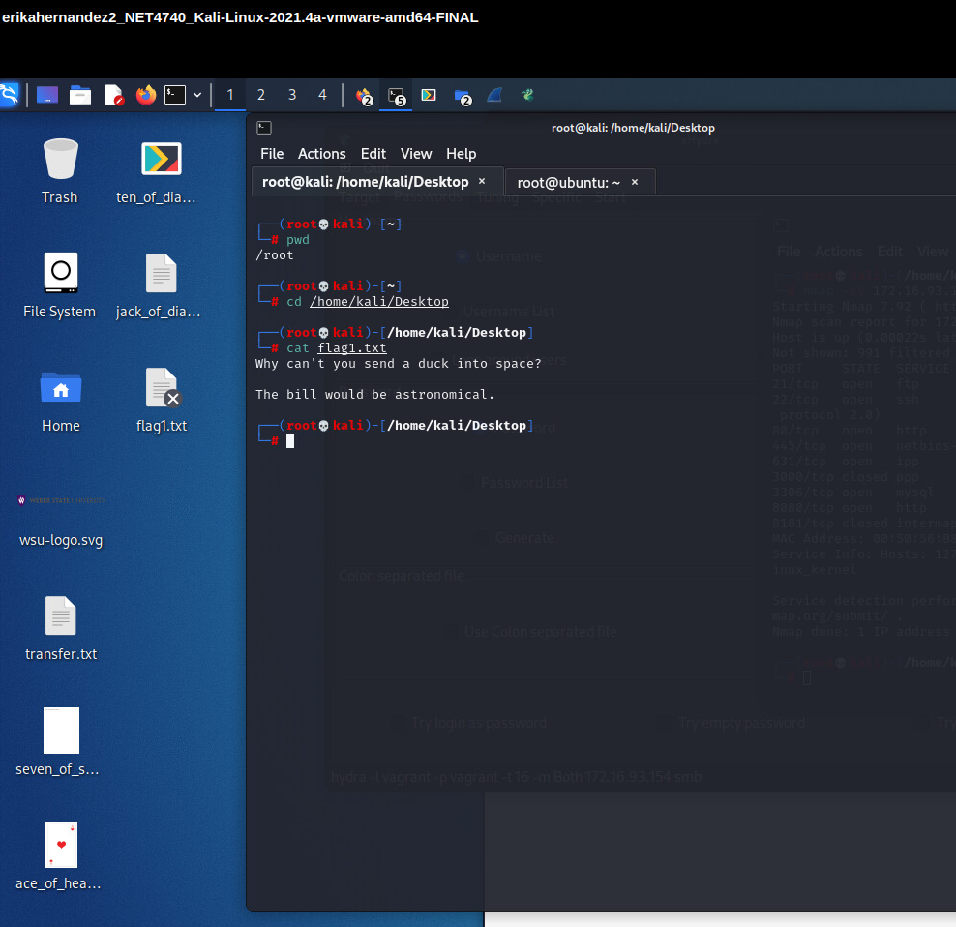Figure 1: flag1.txt - This was the flag I got from the windows machine

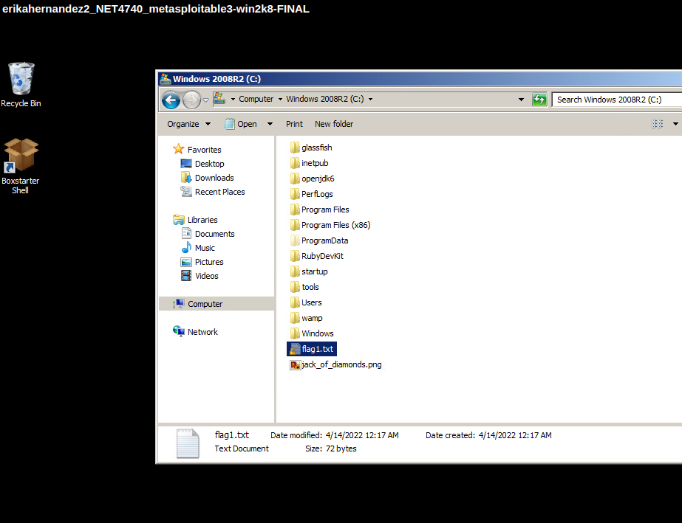flag1- this was in the Windows C:\ but it was a hidden file- I had to figure out how to unhide since this was a Windows 2008 machine

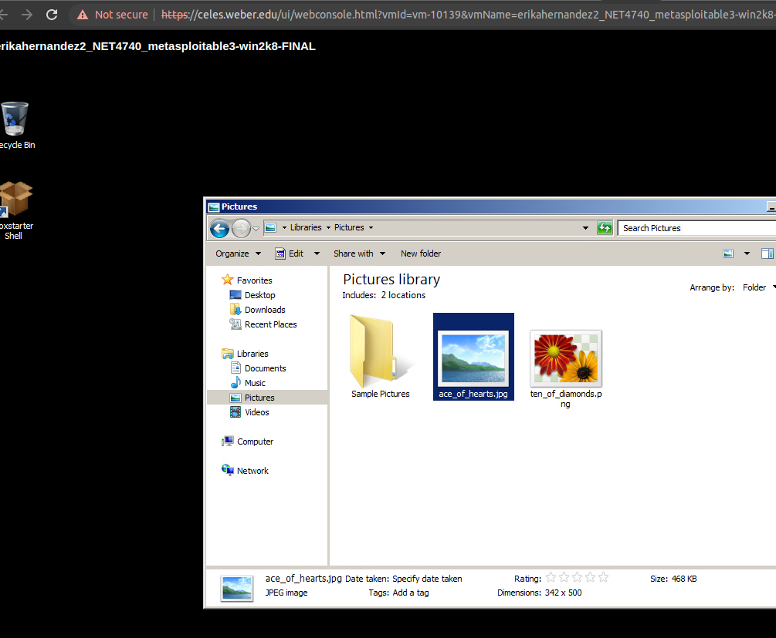I thought these were flags- but they weren't. they looked like them to me so i just took screen shots

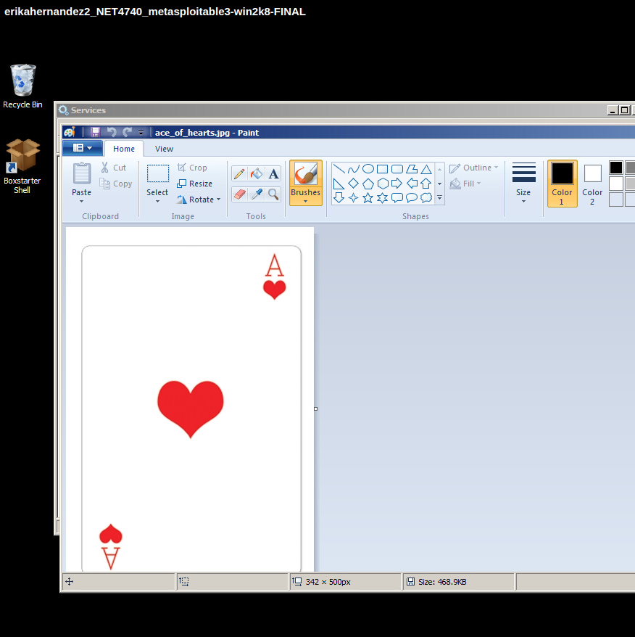Possible Flag? I thought was something – but was nothing.

Question 4 – Image on the desktop
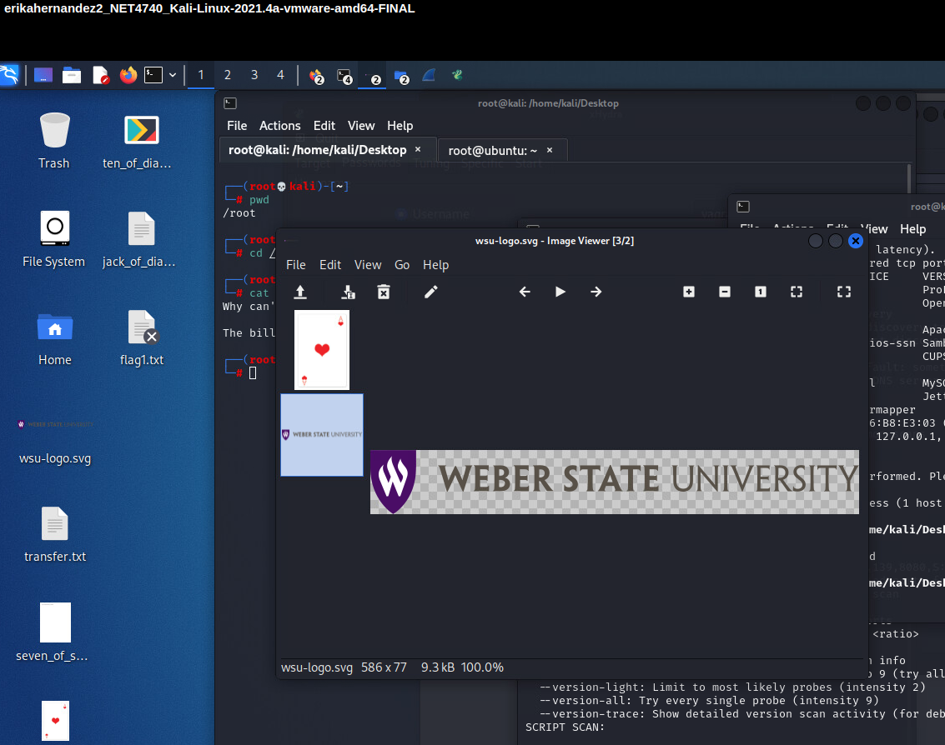

Question 5 – Image that was on the desktop without using the GUI

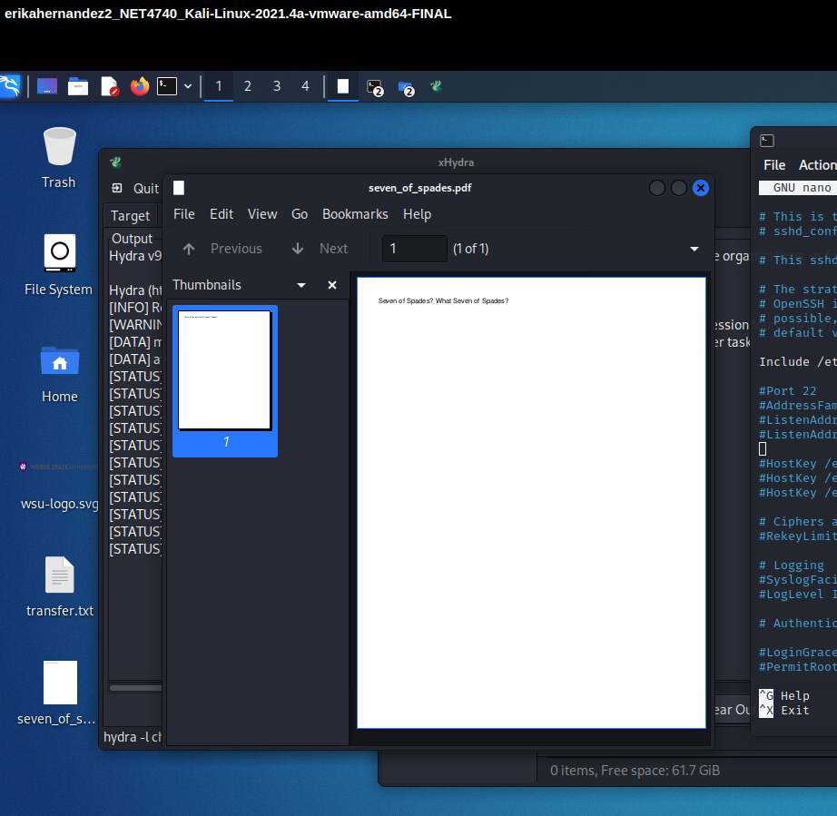The txt file that was on the Kali machine



